Descriptions of Ms. word one by one

**Home tab menu** 

Clipboard 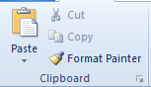

Paste (ctrl +Y): 

Paste the contents of the clipboard.

Cut (Ctrl +X): 

Cut the selection and put it on the clipboard.

Copy (ctrl +C): 

Copy the selection and put it on the clipboard.

Format Painter (ctrl +shift +C): 

Copy formatting from one place and apply it to another.

Double-click on format painter to apply the same formatting to multiple places in the document.

**Front** 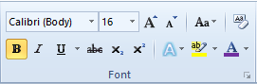

Front (ctrl +shift +F): 

Change the front face.

Font size (ctrl +shift +P): 

Change the font size.

Bold (ctrl +B): 

Make the selected text bold.

Italic (ctrl +I):

Italicize the selected text.

Underline (ctrl +U):

Underline the selected text.

Strikethrough: 

Draw a line through the middle of the selected text.

Subscript (ctrl +=):

Create small letters below the text baseline.

Superscript (ctrl +shift ++):

Create small letters above the line of text.

Grow font (ctrl +>):

Increase the font size.

Shrink font (ctrl +<):

Decrease the font size.

Change case:

Change the selected text to UPPERCASE, lowercase, or other common capitalizations.

Clear formatting:

Clear all the formatting from the selection, leaving only the plain text.

Text effect:

Apply a visual effect to the selected text, glow or reflection.

Text highlights color:

Make text look like it was marked with a highlighted pen.

Font color:

Change the color text.

**Paragraph** 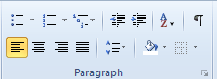

Bullets:

Start a bulleted list.

Click the arrow to choose different bullets styles.

Numbering:

Start a numbered list.

Click the arrow to choose different numbering list.

Multilevel list: 

Start a multilevel list.

Click the arrow to choose different multilevel list style.

Align text lift (ctrl +L): 

Align text to the left.

Center (ctrl +E): 

Center text

Align text right (ctrl +R): 

Align the text to the right.

Justify (ctrl +J): 

Align text to both the text to both the lift and right margins, adding extra space between words and necessary.

This creates a clean look along the left and right side of the page.

Decrease indent: 

Decrease the indent level of the paragraph.

Increase indent: 

Increase the indent level of the paragraph.

Line and paragraph spacing: 

Change the spacing between lines of the text.

Sort: 

Alphabetize the selected text or sort numerical data.

Show \hide (ctrl +*): 

Show paragraph marksand other hidden formating symbols.

Shading 

Colour the background behind the selected text or paragraph.

Border 

Custimize the borders of the selected cells cells or text.

**Styles** 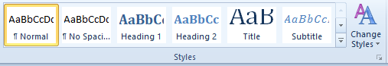

Format styles

Format titles quotes, and other text using this gallery of styles.

Change style 

Change the set of style, colors, fonts, and paragraphs spacing used in this document.

**Editing** 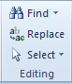

Find (ctrl +F): 

Find text and other content in the document.

Replace (ctrl +H): 

Replace text in the document.

Select: 

Select text and object in the document.

Use select object to allow you to select objects that have been positioned behind the text.

**Insert** 

**Pages** 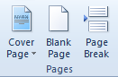

Cover page: 

Insert a fully formatted cover page.

You fill in the title, author, date, and other information.

Blank page: 

Insert a new blank page at the cursor position.

Page breaks (ctrl +Return): 

Start the next page at the current position.

**Tables **

Table: 

Insert or draw a table into the document.

**Illustrations** 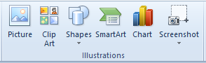

Picture: 

Insert a picture from a file.

Clip art: 

Insert clip art into the document,including drawings, movies, sounds, or stock photography to illturate a specific concept.

Shapes: 

Insert readymade shapes, such as rectangle and circle, arrow, line, flow chart symbol and callouts.

Smart Art:

Insert a smart art graphic to visually communicate information.

Smart art graphics range from graphical list and process diagrams to more complex geaphic, such as vnn diagram and organization charts.

Charts:

Insert a chart to illustrate and compare data.

Bar, pai, line, area and surface are some of the available types.

Screenshot:

Insert a picture of any program that is not minimized to the taskbar.

Click screen clipping to insert a picture of any part of the screen.

**Links** 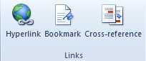

Insert hyperlink: 

Create a link to a web page, a picture, an E-mail address, or a program.

Bookmark: 

Crate a bookmark to assign a name to a specific point in a document.

You can make a hyperlinks that jumped directly to the bookmarked location.

Cross-reference: 

Reffer to item such as headings, tables, and figures by insearting a cross-reference such as, “see table 6 below” or “turn to page 8.”

Cross-refernce are automatically updated if the if the content is moved to another location. By default, cross referance are inserted as hyperlinks.

**Header and footer** 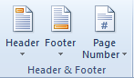

Header: 

Edit the header of the document.

The content in the header will appear at the top of the each printed page.

Footer: 

Edit the footer of the document.

The content in the footer will apper at the bottom of each printed page.

Insert page number: 

Insert page number into the document.

**Text** 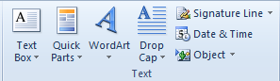

Text box: 

Insert preformated text boxes.

Quick parts: 

Insert resuable piece of content including field, document properties such as title and author, or any other preformated snippets you create.

Word art: 

Insert decorative text in your document.

Drop cap: 

Create a large capital letter at the beginning of a paragraph.

Signature line: 

Insert a signature line that spacifies the indivadual who must sign.

Inserting a digital signature requires that you obtain a digital id, such as one from a certified microsoft partner.

Insert date & time: 

Insert the current date or time into the current document.

Insert object: 

Insert an embedded objeat.

**Symbols** 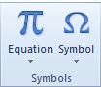

Equation (ctrl +=):

Insert common methematical equations or build up your equation using a liberary of maths symbol.

Insert symbol: 

Insert symbol that are not on your keyboard, such as copyright symbols, treadmark symbols, paragraph marks, and unicode characters.

**Page layout **

**Themes** 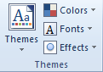

Themes: 

Change the overall design of the entire document, including colors, fonts, and effects.

Theme colors: 

Change the color of the current theme.

Theme fonts: 

Changes the fonts of the current themes.

Theme effect: 

Change the effects current theme.

**Page setup** 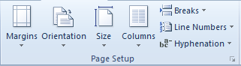

Margins 

Select the margins size for the entire document or the current document document.

Page orientation: 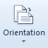

Swicth the pages between the portriate and landscape layout.

Page size: 

Choose the paper size of the current section.

To apply a specific paper size to all section in the document, click more paper sizes.

Columns: 

Split text into two or more columns.

Insert page and section brakes: 

Add page, section, column brakes to a document.

Line number: 

Add line number in the margin alongside of each line of the document.

Hyphenation: 

Turn on hyphenation, which allows woed to break lines between the syllabls of the word.

Books and magazines hyphenate there text in order to have more uniform spacing between words.

**Page background:** 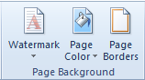

Watermark: 

Insert ghosted text behind the content of the page.

This is often used to indicate that a document is to be treated specially, such as confedintial and urgent.

Page color: 

Choose a color for the background of the page.

Page border: 

Add or change the border around the page.

**Paragraph:** 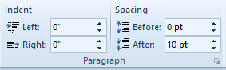

Indent left: 

Move in the lift side paragraph by a certain amount.

To change the margines for the whole document, click the margins buttons.

Indent right: 

Move in the right side parsgraph by a certain amount.

To change the margins for the whole document, click the margins buttons.

Spacing before: 

Change the spacing between paragraph by adding space above the selected paragraph.

Spacing after: 

Change the spacing between paragraph by adding space below the selected paragraph.

**Arrange** 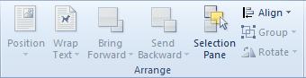

Object position: 

Position the selected object on the page.

Text is automaticaly set to wrap around the object.

Wrap text: 

Change the way text wraps around the selected object.

To configure the object so that it move along with the text around it, select “in line with text.”

Bring forward: 

Bring the selected object to the fordward one level to the font of all object.

Send backward: 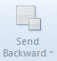

Send the selected object back one level or to the back of all object.

Selection pan: 

Show the selection pane to help select individual object and to change their order and visibilty.

Align: 

Align the edges of multiple selected object.

Group: 

Group object together so that they can be treated like a single object.

Rotate: 

Rotate or flip the selected object.

**References **

**Table of content** 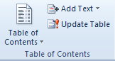

Table of contents: 

Add a table of contant to a document.

Once you have added a table of content, click the add text button to add entries to the table.

Add text: 

Add the current paragraph as an entry in table of content.

Update table: 

Update the table of content so that all entries refer to the current page number.

**Footnotes** 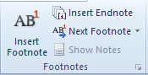

Insert footnotes (alt +ctrl +F): 

Add a footnote to a document.

Footnotes are automatically renumbered as you move textaround the document.

Insert endnote (alt + ctrl +D): 

Add an endnote to the document.

Endnotes are plased at the end of the document.

Next footnote: 

Navigate to the next footnote in the document.

Click the arrow to nevigate to the previous in the document, or to nevigate to the next or previous endnote.

Show notes: 

Scrol the document to show where the footnotes or endnotes are located.

**Citations & bibliography** 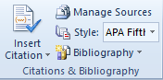

Insert citation: 

Cite a book, journal article, or other periodical as the source for a pice of information in the document.

Choose from the list of sources you have a created or enter information for a new sources.

Word formats the citation according to the style you have selected.

Manage sources: 

View the list of all the sources cited in the document.

Bibliography style: 

Choose the style of citation to use in the document.

Popular choice include APA style, chicago style, and MLA style.

Bibliography: 

Add a bibliography, which list all the sources cited in the document.

**Captions** 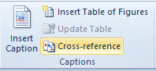

Insert caption: 

Add a caption to a picture or other image.

A caption is line of text that appers below an object to describe it.

Table of figure dialogs: 

Insert a table of figure into the document.

A table of figure includes the list of all of the figure, table or equation in the document.

Update table of figure: 

Update the table of figure to include all of the entries in the document.

Cross reference: 

Reffer to item such as headings, tables, and figures by insearting a cross-reference such as, “see table 6 below” or “turn to page 8.”

Cross-refernce are automatically updated if the if the content is moved to another location. By default, cross referance are inserted as hyperlinks.

**Index** 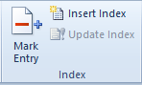

Mark entry (alt +shift +X): 

Include the selected text in the indext document.

Insert index: 

Insert an index into the document.

An index is a list of keyuwords found in the document along with the page number the woeds appers on.

Update index: 

Update the index so that all the entries refer to the correct page number.

**Table of authorities** 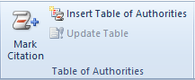

Mark citation (alt +shift +I): 

Add the selected as an entry in the table of authorities.

Insert table of authorities: 

Insert the table of authorities into the document.

A table of authorities lists the case, status and other authorities cited in the document.

Update table of authorities: 

Update the table of authorities to include all of the citation in the document.

**Mailings **

**Create** 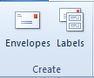

Create Envelopes: 

Create and print envelope.

Labels: 

Create a print lables.

You can select from a number of popular label style and shapes.

**Start mail merge** 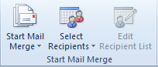

Start mail merge: 

Start a mail merge to create a form lettre which to print or e-mail multiple time, sending each copy to a different recipitent

You can insert field, such as name or address, which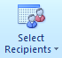 word will replace automatically with information from a database or contact list for each copy of the form letter.

Select recipients:

Choose the list of people to intent to send the letter to.

You can type your own list, use your outlook contact, or connect to a database.

Edit recipient list: 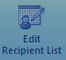

Make changes to the list of recipints and decide which of them should recive your letter.

You can also sort, filter, find,and remove dupiclates, or vaildate addsess from the list.

**Write & insert fields** 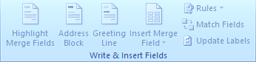

Highlight merge field: 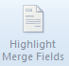

Highlight the fields you have inserted into the document.

This make it easy to see what part of your form letter will be replaced by information from the recipient list you have choosen.

Address block: 

Add an address to your letter.

You spcify the formating and location, and word will replace it with actual address from your recipient list when you finish the mail merge.

Greeting line: 

Add a greeting line such “dear <<first name >>,” to your document.

Insert merge field: 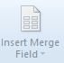

Add any field from your recipient list ti document, such as “last name,” “home phone” “company name,” or any other field.

When you finish the mail merge word will replace these fields with the actual information from the recipient list.

Rules: 

Spacify rules to add decision-making ability to the mail merge.

For intense, you could use if… then…els to check the address of recipient and show a local phone number for recipients you and an international phone number for recipients outside of your country.

Match fields: 

Match fields allows you to tell word the meaning of different fields in your recipients list.

For example, you indicate thet your custom field “home” is equivalent to normal-build in field “home phone.”

Update labels: 

If you are creating labels, update all the lables in the document to use information from the recipients lists.

For a mail merge to a printed letter or e-mail, this commond is not necessary.

**Preview result** 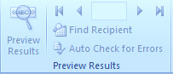

View merged data: 

Replace your merged field in your document with actual data form your recipient list so you can see what it look like.

Go to record: 

Preview a specific record in the recipient list.

Find recipient: 

Find and preview a specific record in the recipient list by searching for text.

Check for error (alt +shift +K): 

Spacify how to handle errors that occur when completing the mail-merge.

You also have option of simulating the mail merge to see if any error would occor.

**Finish **

Finish & merge: 

Complete the mail merge.

You can create a seprate document for each copy of letter, send them directly to the printer, or send them via e-mail.

**Review **

**Proofing** 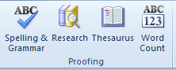

Spelling & grammar (F7) 

Check the spelling and grammer of text in the document.

Research (alt +click): 

Open the research task pane to search through reference materials, such as dictionaries, encyclopedia, and translation services.

Thesaurus (shift +F7): 

Suggests other word with a similar meaning to the word you have selected.

Word count: 

Find out the number of words, character, paragraph and lines in the document.

You can also find the words count in the status bar at the botton of the window.

**Language** 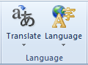

Translate: 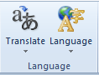

Translate words or paragraph, into a different leanguage using bilingual dictionaries or machine translation.

Language: 

Select language options.

**Comments** 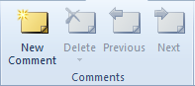

Insert comments: 

Add a comment about a selection.

Delete comment: 

Delete the selected comment.

Previous comment: 

Navigate to the previous comment in the document.

Next comment: 

Navigate to the next comment in the document.

**Tracking** 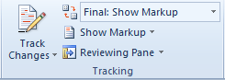

Track changes: 

Track all the changes to the document, including insertations, deletations, and formating changes.

Display of review: 

Choose how to view the proposed changes to the document.

Final showes the with all proposed changes included; original showes the document before any changes were made.

The markup showes what changes have been proposed.

Show markup: 

Choose what kind of markup to show in the document.

You can hide or show comments, insertation and delateions, formating changes, and other kinds of markup.

Reviewing pane: 

Show revision in a seprate window.

**Changes** 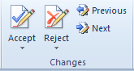

Accept and move to next: 

Accept the current changes and move to the next proposed changes.

Click the arrow to Accept many changes at once.

Reject and move to next: 

Rejact the current changes and move to the next proposed changes.

Click the arrow to reject many changes at once.

Previous change: 

Navigate to the previous revision in the document so that you can accept and reject it.

Next change: 

Navigate to the next revision in the document so that you can accept and reject it.

**Compare **

Compare: 

Compare and combine multiple versions a of document.

**Protect** 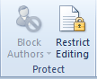

Block authors:

Block other authors from editing the selected text.

Restrict editing:

Restrict How people edit or format specific parts of the document.

You can prevent formating changes, forces all changes to be tracked, or only enabling commenting.

**View **

**Document views** 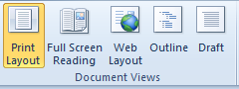

Print layout: 

View the document as it will apper on the printed page.

Full screen reading: 

View the document in full screen reading view in order to maximize the spase avaliable for reading or commenting on the document.

Web layout: 

View the document as it would look as the web page.

Outline view: 

View the document as an outline and show the outling tools.

Draft view: 

View the document as a draft to quickly edit the text.

Certain elements of the document such as headers and footers will not be visible in view.

**Show** 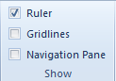

View ruler:

View the rulers, use to measure and line up object in the document.

Gridlines:

Turn on gridlines to which you can align objects in the document.

Navigation pane:

Open the navigation pane which allows you to navigate through the document by headings, by page, or by searching for the text or objects.

**Zoom** 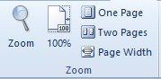

Zoom: 

Show the zoom dialog box to spacify the zoom level of the document.

In most cases, you can also use the zoom control in the status bar at the bottom of the window to quickly zoom the document.

100%: 

Zoom the document to 100% of the normal size.

One page: 

Zoom the document so that an entire page fits in the window.

Two pages: 

Zoom the document so that two pages fits in the window.

Page width: 

Zoom the document so that the width of the page matches the width of the window.

**Window:** 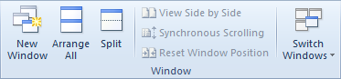

New window: 

Open a new window contaning a view of the current document.

Arrange all: 

Tile all open program windows-side by-side on the screen.

Split window: 

Split the current window into two parts so that you can view different sections of the document at the same time.

View side-by-side:

View the document side by side so that you can compare their contents.

Synchronous scrolling:

Synchronous the scrolling of two documents, so that they scroll together.

To enable this feature, turn on view side-by-side.

Reset window position:

Reset window position of the document being compared side-by-side so that they share the screen equally.

To enable this feature turn on view side-by-side